Smooth Muscle Cell Model
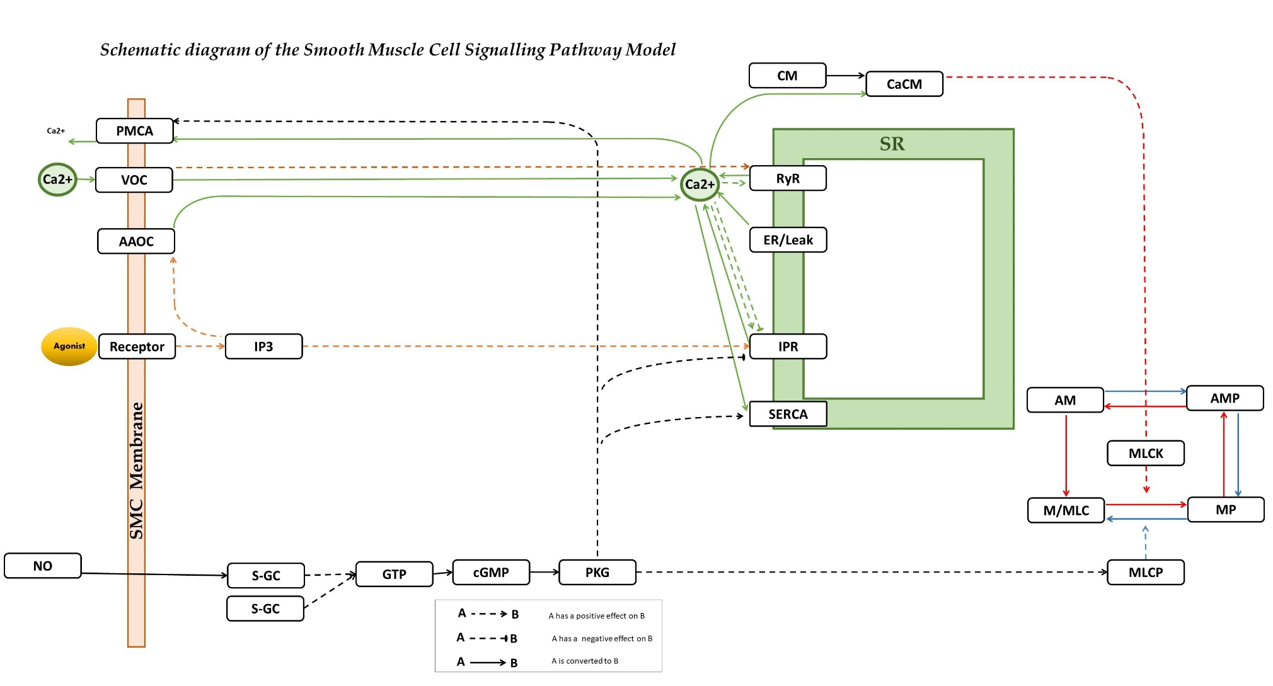

This model is an update on research conducted by Hai and Murphy (1988), Yang et al. (2005), and Wang et al. (2010). Wang et al.'s (2010) model was emploied to simulate the increase in extracellular calcium levels $({[{Ca}^{2+}]}_{i}$), observed as oscillatory ${Ca}^{2+}$ waves triggered by agonists and high external potassium (KCL). By incorporating this model into the one developed in Yang's (2005) study, It is aimed to comprehend how nitric oxide (NO) released by endothelial cells influences vascular smooth muscle cells. This integration, along with consideration of Hai and Murphy’s (1988) model for actin-myosin cycling, enables us to simulate how NO affects the behaviour of smooth muscle cells in regulating blood vessel activity.
This model is an update on a Vascular Smooth Muscle FTU on the Physiome, located at the link below:
https://models.physiomeproject.org/workspace/6b0/file/a8a92308e217ac5626809237dd90a31240b22834/VSM_ftu
References:
Hai, C. M., & Murphy, R. A. (1988). Cross-bridge phosphorylation and regulation of latch state in smooth muscle. American Journal of Physiology-Cell Physiology, 254(1), C99-C106.
Yang, J., Clark, J. W., Bryan, R. M., & Robertson, C. S. (2005). Mathematical modeling of the nitric oxide/cGMP pathway in the vascular smooth muscle cell. American Journal of Physiology-Heart and Circulatory Physiology, 289(2), H886-H897.
Wang, I. Y., Bai, Y., Sanderson, M. J., & Sneyd, J. (2010). A mathematical analysis of agonist-and KCl-induced ${Ca}_{2}^{+}$ oscillations in mouse airway smooth muscle cells. Biophysical journal, 98(7), 1170-1181.

